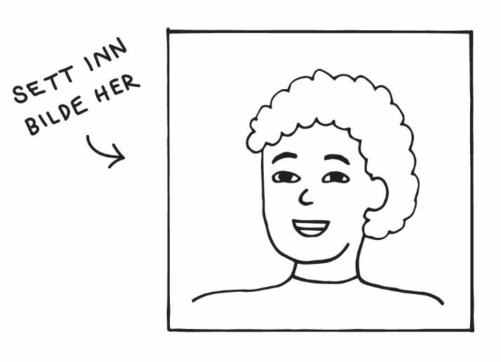
George Tiston
Address Møllergata 3d, 0179 Oslo
Phone +47 767 67 686
Email george.tiston@gmail.com
Date of birth 24.02.1999

EDUCATION

09.2018–09.2020 Birbeck College, London
Majored in Economics and Physics

09.2015–09.2018 Emanuel School
Secondary School
EXPERIENCE

09.2020–now Chef, Tunco Oslo Street Food
Part-time

02.2018–09.2020 Waiter and bartender, Limonchella Restaurant, London
Part-time. I waited tables, served food and mixed cocktails in the bar

04.2017–06.2018 Shop Assistant, London Harrods Accessories
Part-time. Managed the cashier, customer service and cleaning

OTHER

Languages English mother tongue
French intermediate level, written and orally

Computer skills Microsoft Excel, Word, Power Point, Adobe Photoshop, Basic HTML

REFERENCES

Marius Hansen: Manager, Tunco Oslo Street Food | Phone: +47 999 99 999 | marius@tunco.no
Lionel Dominiki: Owner, Limonchella Restaurant | Phone: +44 000 00 000 | lionel@limo.uk

